Experiment No 6

Title: User Authentication and Authorization in the GrocerySpot App

Objective:
To implement data security with authentication and authorization in the GrocerySpot app.

Theory:

User Authentication and Authorization are essential components in applications like GrocerySpot for several reasons:

- Protecting User Data: GrocerySpot may contain sensitive information such as user profiles, order history, and payment details. Authentication ensures that only authorized individuals have access to this data, maintaining user privacy and security.

- Preventing Unauthorized Access: Authentication verifies the identity of users, preventing unauthorized access to the app's features and data. This helps protect against malicious activities and ensures that users can trust the integrity of their interactions with the app.

- Personalization and Customization: Authentication allows GrocerySpot to personalize the user experience based on individual preferences and behavior. Authenticated users can access personalized recommendations, saved shopping lists, and customized settings, enhancing their overall shopping experience.

Implementing user registration and login functionality in the app:

GrocerySpot seamlessly integrates authentication services using Firebase Authentication. Firebase Authentication provides a robust and secure framework for user identity verification, offering a streamlined solution for user authentication needs. The implementation involves user email and password authentication, ensuring a straightforward method for user identity verification.

Firebase Authentication not only simplifies the authentication process but also enhances the overall security of GrocerySpot. With Firebase, sensitive user data, such as login credentials, is handled and stored securely, adhering to best practices in data protection. This robust authentication mechanism significantly contributes to the privacy and integrity of user interactions within the app.

Moreover, Firebase Authentication supports various authentication methods beyond email and password, including social media logins (such as Google and Facebook). This flexibility provides users with convenient options for accessing GrocerySpot, aligning with modern user preferences and expectations.
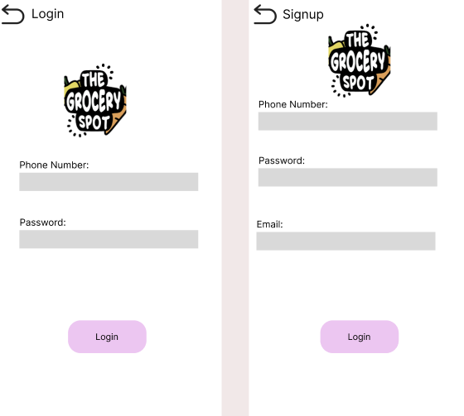

Using a standard secure authentication mechanism:

Firebase Authentication employs industry-standard secure authentication mechanisms to ensure the confidentiality and integrity of user data. It primarily relies on OAuth 2.0 and OpenID Connect protocols, which are widely recognized standards for secure authentication and authorization.

Key mechanisms used by Firebase Authentication include:

OAuth 2.0: GrocerySpot utilizes OAuth 2.0 for authentication, which involves redirecting users to a sign-in page hosted by identity providers like Google or Facebook. Upon successful authentication, Firebase receives an authorization code, which is exchanged for an access token used to access user information securely.

Token-based Authentication: Firebase Authentication issues JSON Web Tokens (JWTs) as authentication tokens after successful user authentication. These tokens contain user information and are securely transmitted between the client and server, ensuring authenticity and integrity.

Secure Communication: All communications between GrocerySpot, Firebase Authentication servers, and identity providers are secured using HTTPS (TLS/SSL). This ensures that data transmitted during the authentication process remains confidential and cannot be intercepted or tampered with.

Restricting access to certain app features based on user roles or permissions:

GrocerySpot implements role-based access control to restrict access to certain app features based on user roles or permissions. For example, an admin user may have permission to manage products, view analytics, and modify user accounts, while a regular user may only have access to shopping functionalities.

By enforcing granular access control mechanisms, GrocerySpot ensures that users can only perform actions that are authorized for their role. This helps prevent unauthorized access to sensitive features and data, maintaining the security and integrity of the app.

Conclusion:

In conclusion, the implementation of User Authentication and Authorization in the GrocerySpot app plays a critical role in ensuring data security, user privacy, and trustworthiness. By integrating Firebase Authentication, GrocerySpot provides a seamless and secure authentication experience for users, while also supporting various authentication methods to accommodate diverse user preferences.

Additionally, by enforcing role-based access control, GrocerySpot restricts access to certain features based on user roles or permissions, preventing unauthorized actions and maintaining the integrity of the app. Overall, User Authentication and Authorization are foundational elements that contribute to the overall security and user experience of GrocerySpot, fostering trust and confidence among users.

